**HEXADECIMAL TO DECIMAL CONVERSION**

**EXP NO: 27**

**AIM:**To write a C program to implement hexadecimal to decimal conversion.

**ALGORITHM:**

1. Start from the right-most digit. Its weight (or coefficient) is 1.
2. Multiply the weight of the position by its digit. Add the product to the result.

(0=0, 1=1, 2=2, … 9=9, A=10, B=11, C=12, D=13, E=14,F=15)

1. Move one digit to the left. Its weight is 16 times the previous weight.
2. Repeat 2 and 3 until you go through all hexadecimal digits.

**PROGRAM:**

#include<stdio.h>

int

main()

{

int n;

printf("enter the hex decimal

number");

scanf("%x",&n); printf("the decimal value

is:%d",n);

return 0;

}

**INPUT** & **OUTPUT:**

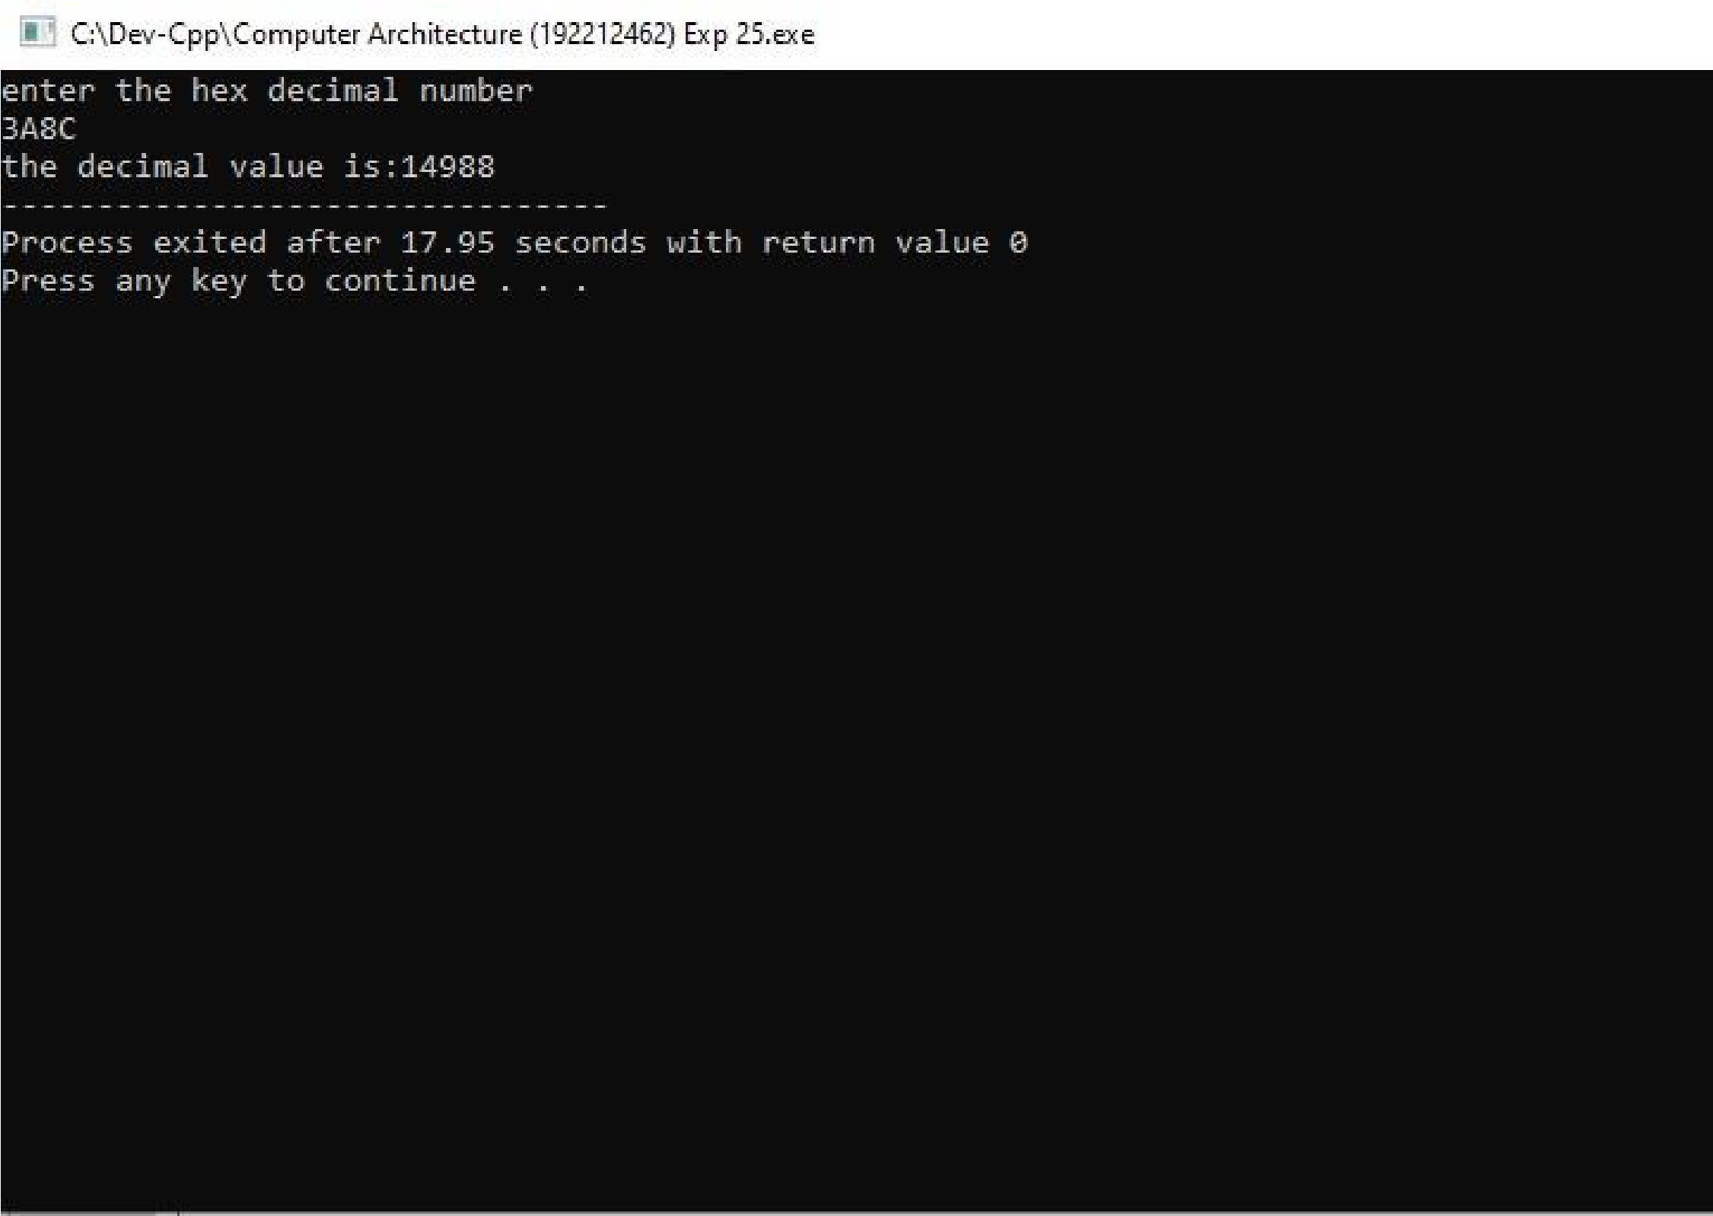

**RESULT:** Thus the program was executed successfully using DevC++.